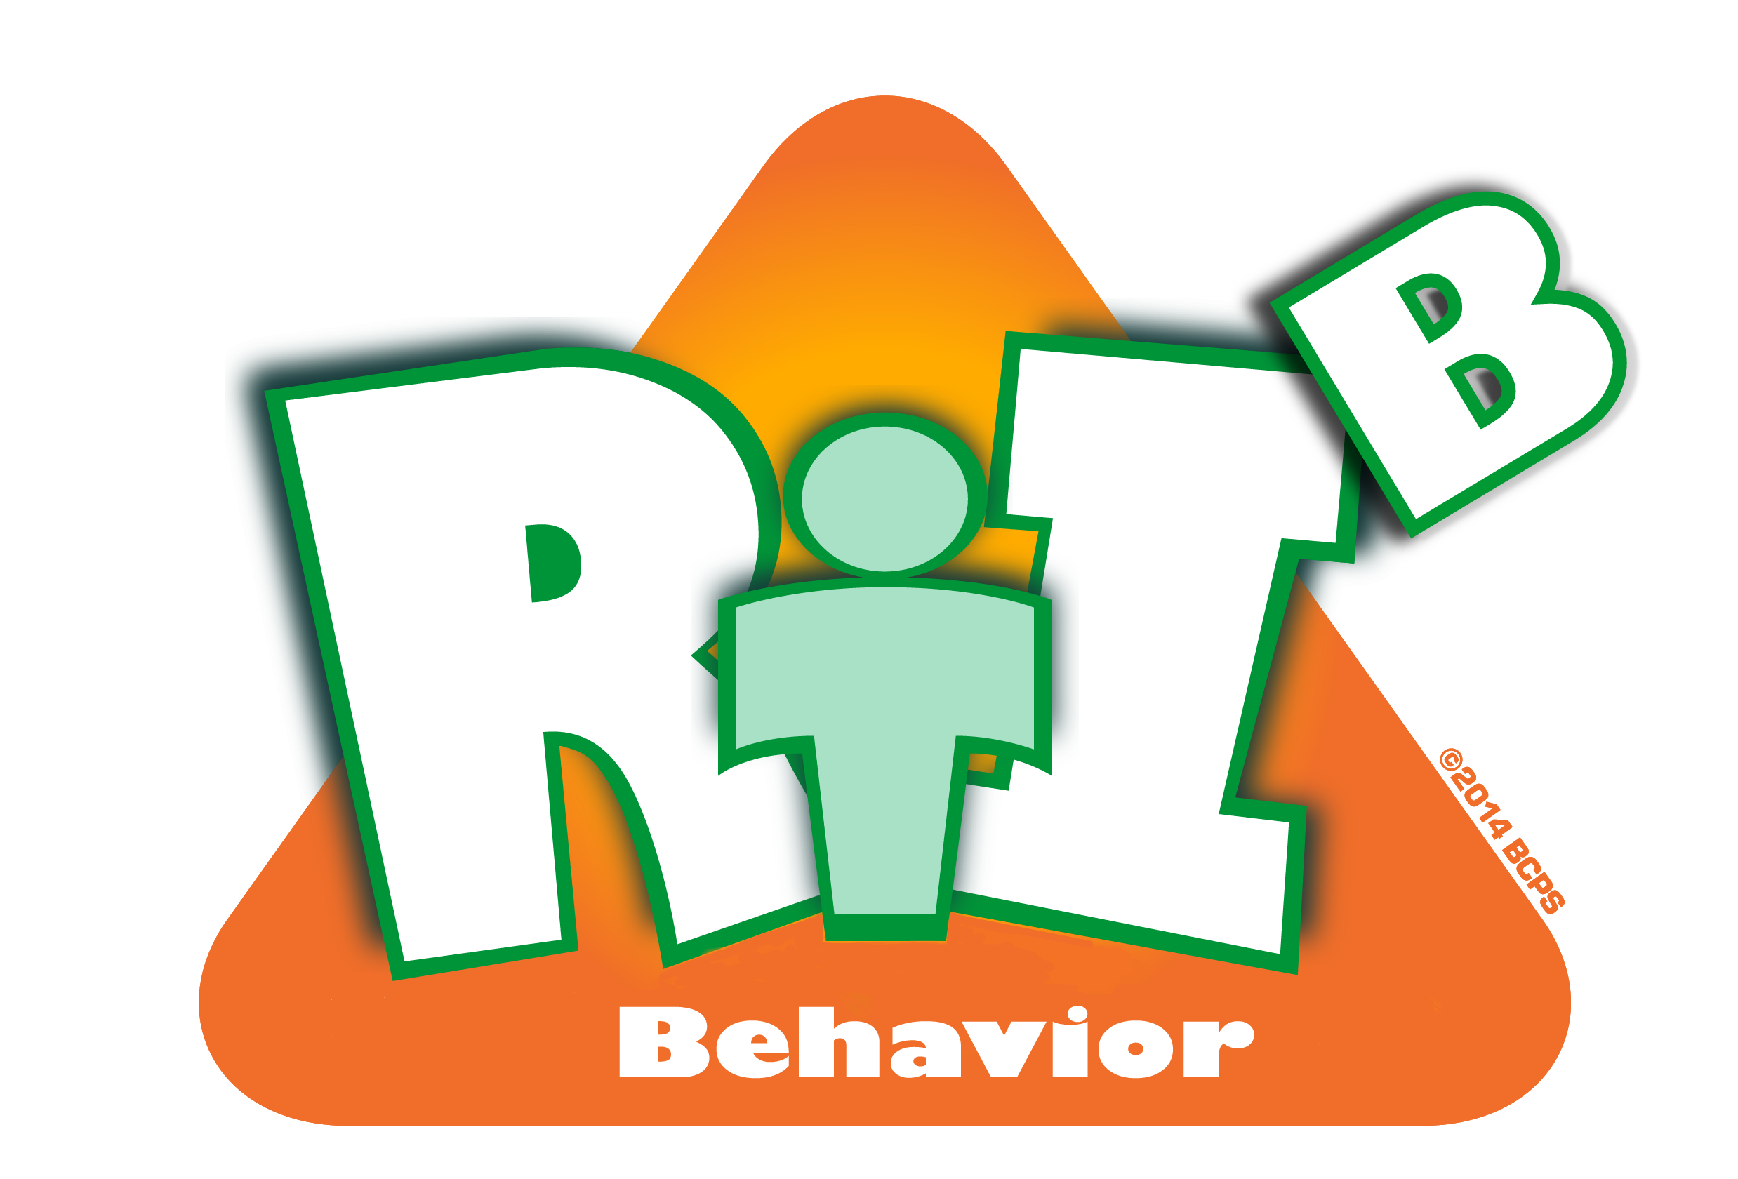
Broward County Public Schools
RtI:B Action Plan Guide
CE
1
Critical Element

Teaming
Teaming
Critical Element | Considerations | To-do List | Person Responsible | Follow up or  Completion Date
 | Team has administrative support | Determine which model to use to address Tier 1 Behavior Curriculum consistently
 | Team has administrative support | Set meetings when Principal can attend
 | Team has administrative support | Principal watches “RtI:B For Principals” Brainshark
 | Team has regular meetings | Determine meeting schedule (min 4 per year)
 | Team has broad representation | Determine core team members
 | Team has broad representation | Seek representative from all stakeholders
 | Team has clear purpose/goals | Develop team rules and goals
 | Team has clear purpose/goals | Create member roles & responsibilities
 | Team is appropriately trained to complete their responsibilities | Train all members in “RtI:B 101” Brainshark, and “Big 5 Brainshark”
 |  | All members complete “4 Step Problem Solving Process Brainshark”
 |  | Have a plan for member attrition and how to train new members “New Team Member” Brainshark
 | Other:

