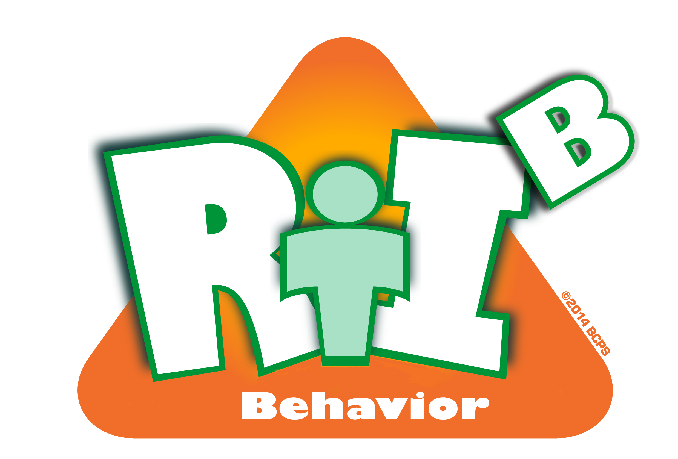
Broward County Public Schools
CE
10
Critical Element

RtI:B Action Plan Guide

Evaluation Planning
Evaluation Planning
Critical Element | Considerations | To-do List | Person Responsible | Follow up or  Completion Date
 | All stakeholders (students, staff, families) are aware of your school’ behavior curriculum | Survey staff, students and families
 |  | Provide method to receive and address feedback
 | All students and staff can quickly identify school-wide expectations and location-specific rules | Teach expectations and rules in behavior lesson plans
 |  | Post and “market” expectations and rules
 | Staff uses the reward system with fidelity and consistency | Include staff in development and provide method for feedback
 | Staff uses the reward system with fidelity and consistency | Teach all staff and reward correct usage

 | Staff understands and correctly uses the discipline system (minor, moderate and office-managed referrals | Include staff in development and provide method for feedback
 |  | Teach all staff and reward correct usage
 | Evaluate staff implementation and student outcomes of behavior | Create methods for data collection and analysis
 | Other:
 | Other:

