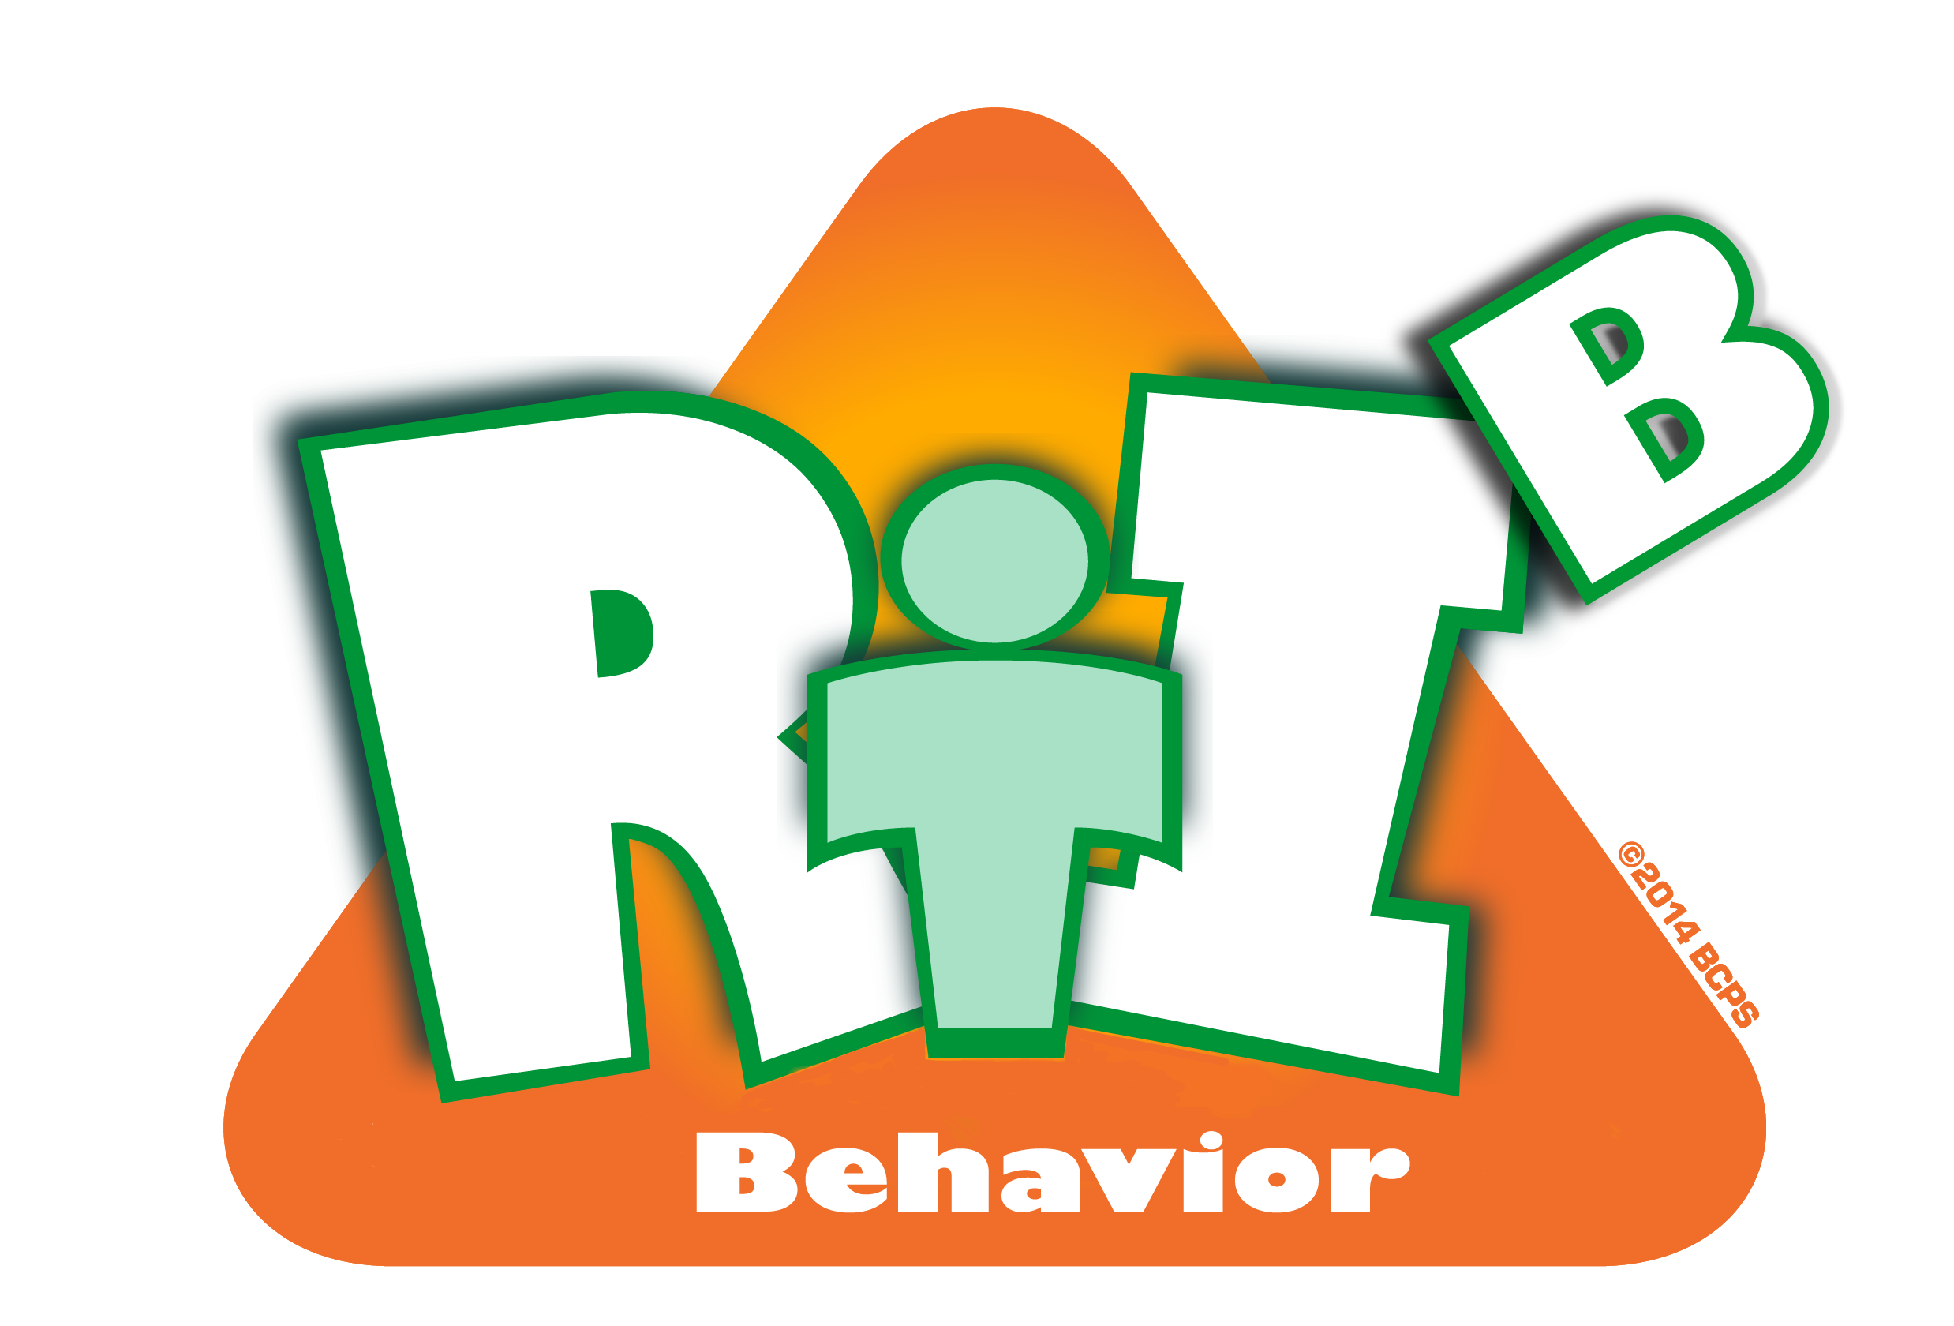
Broward County Public Schools
RtI:B Action Plan Guide

Faculty Commitment
CE
2
Critical Element
Faculty Commitment
Critical Element | Considerations | To-do List | Person Responsible | Follow up or  Completion Date
 | Representation from all staff members | Ensure all areas in school are invited to participate
 | Representation from all staff members | Present at staff, faculty and team meetings (grade levels, paras, support, etc.)
 | Representation from all staff members | Develop a method to collect and address feedback
 | Data collection (survey) of staff knowledge, skills, and opinions of RtI:B | Provide a staff survey of knowledge, skills, and opinions to collect current data about staff (Pre-test)
 |  | Staff presentation to ensure all staff have same understanding of RtI:B
 | Staff voting on SPBP plan | Vote on adoption of SPBP for next year in April of each year
 | Team to meet a minimum of 4 times a year to address behavior data and modify behavior plan as needed | Schedule meeting in SPBP and follow up in school year.
 | Data sharing a minimum of 3 times per school year for all staff on outcomes of RtI:B activities | Schedule data sharing session as part of faculty meetings; add to Agenda items.
 | Other:
 | Other:

