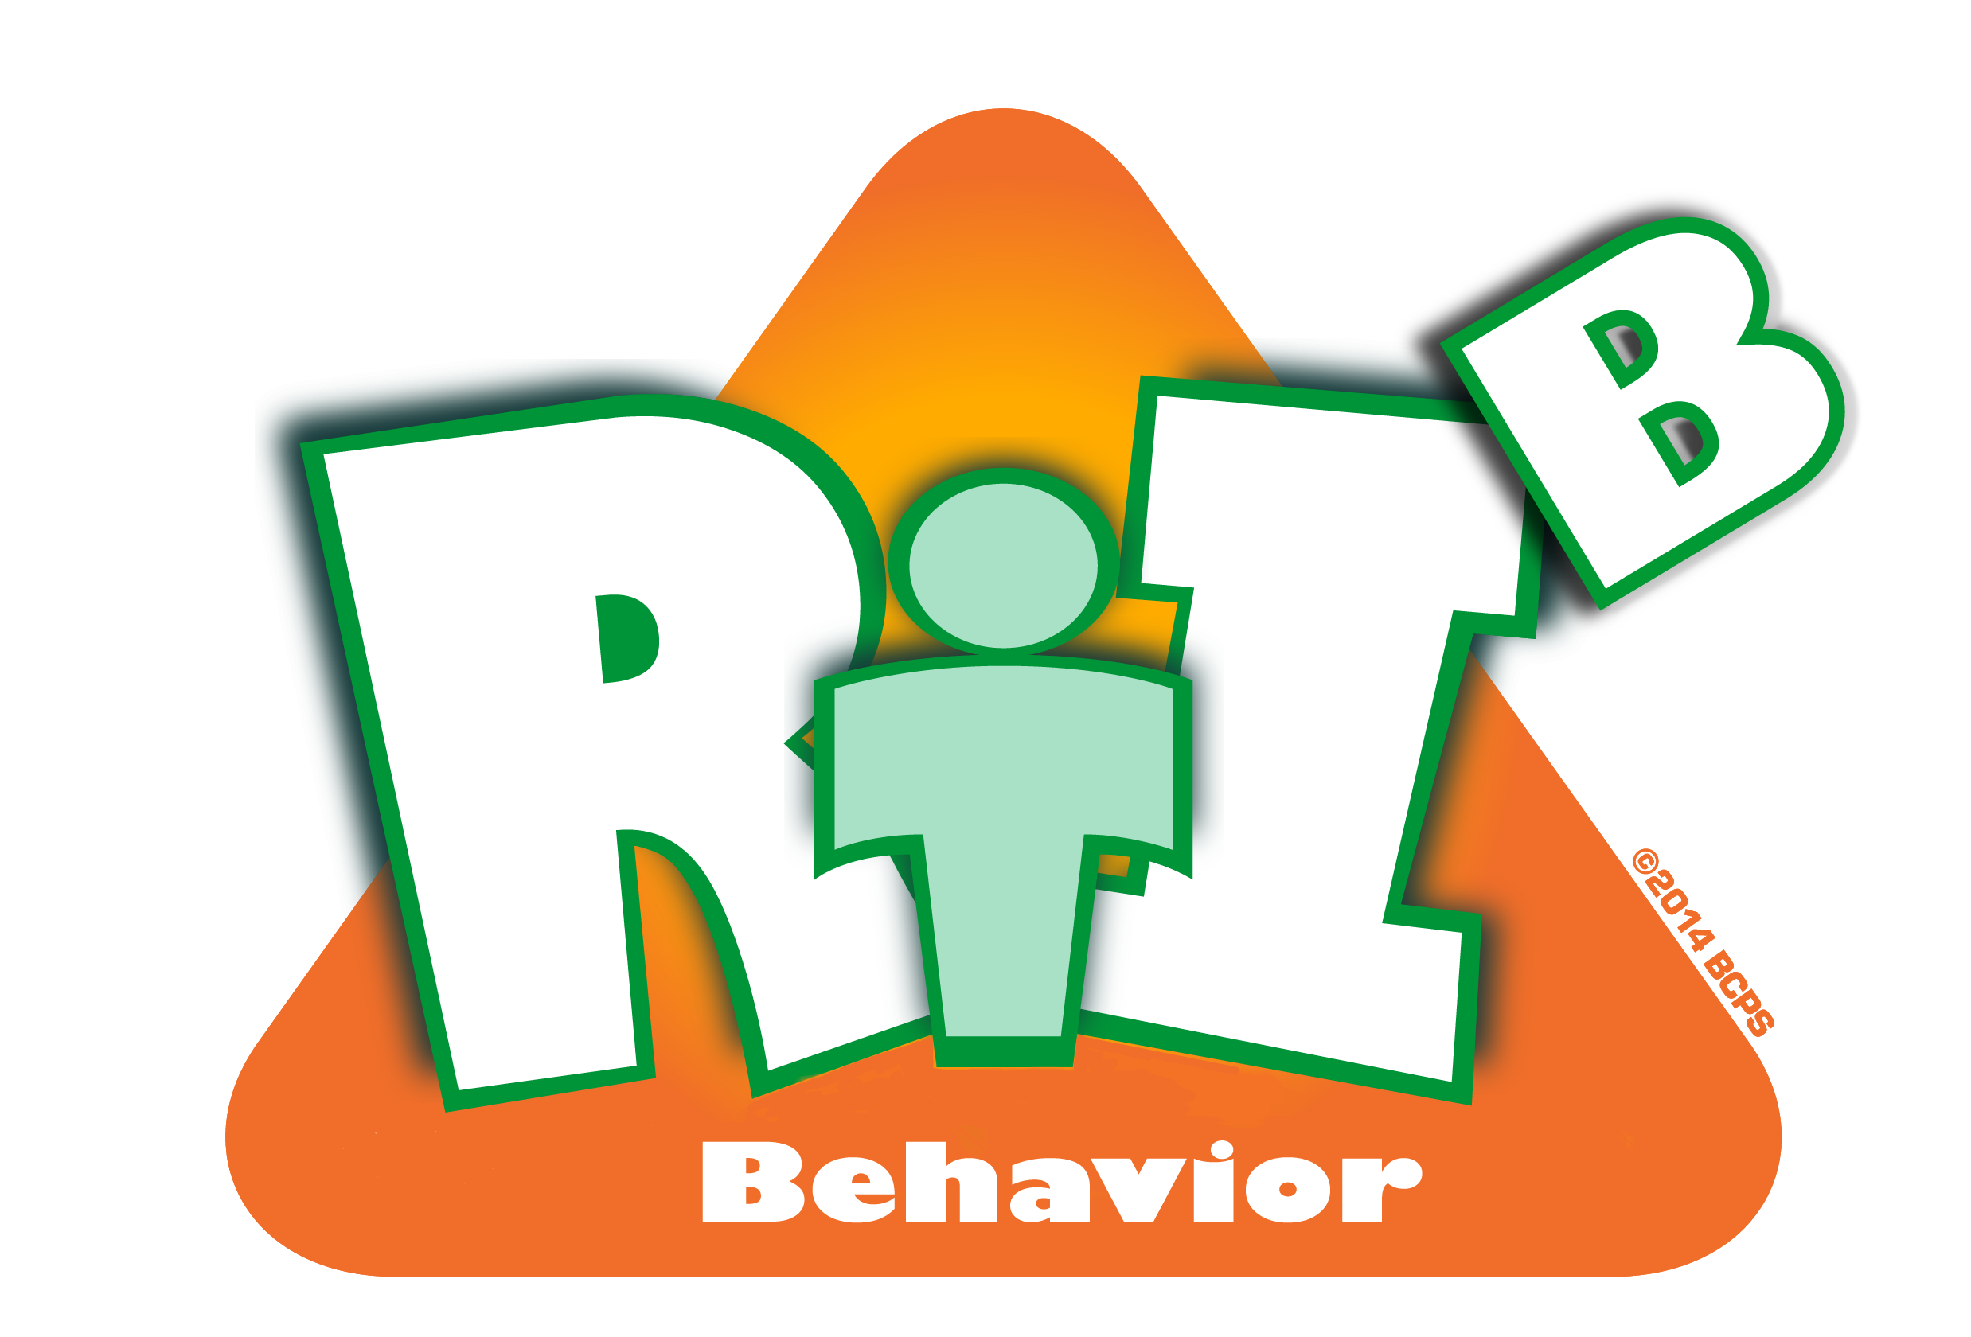
Broward County Public Schools

RtI:B Action Plan Guide
CE
3
Critical Element

Discipline Procedures
Discipline Procedures
Critical Element | Considerations | To-do List | Person Responsible | Follow up or  Completion Date
 | Discipline process is in narrative form or depicted in graphic form  (Discipline Flow Chart) | Include MINOR and MODERATE Staff-managed misbehaviors as well as Office Discipline Referrals (ODRs)
 |  | Develop a plan to teach and disseminate to al staff
 |  | Develop a plan to teach students
 | The process includes documentation procedures | Create an easy and quick method for staff to document all levels of discipline
 | Discipline referral forms are completed accurately | Train staff on accurate completion of referrals forms
 | Discipline referral forms are completed accurately | Develop a procedure to review and provide feedback regarding accuracy of ODRs

 | Behaviors are defined | Provide staff a clarification of behavior in terms that are observable and measurable
 | Minor/major behaviors are clearly identified and consequences understood by students and staff. | Teach staff and students definitions of MINOR and MODERATE Staff-managed misbehaviors as well as Office Discipline Referrals (ODRs)
 | Staff are provided and taught an array of appropriate responses to minor misbehaviors | Supply staff with menu consequences as well as opportunities to employ accumulative consequences
 | Other:

