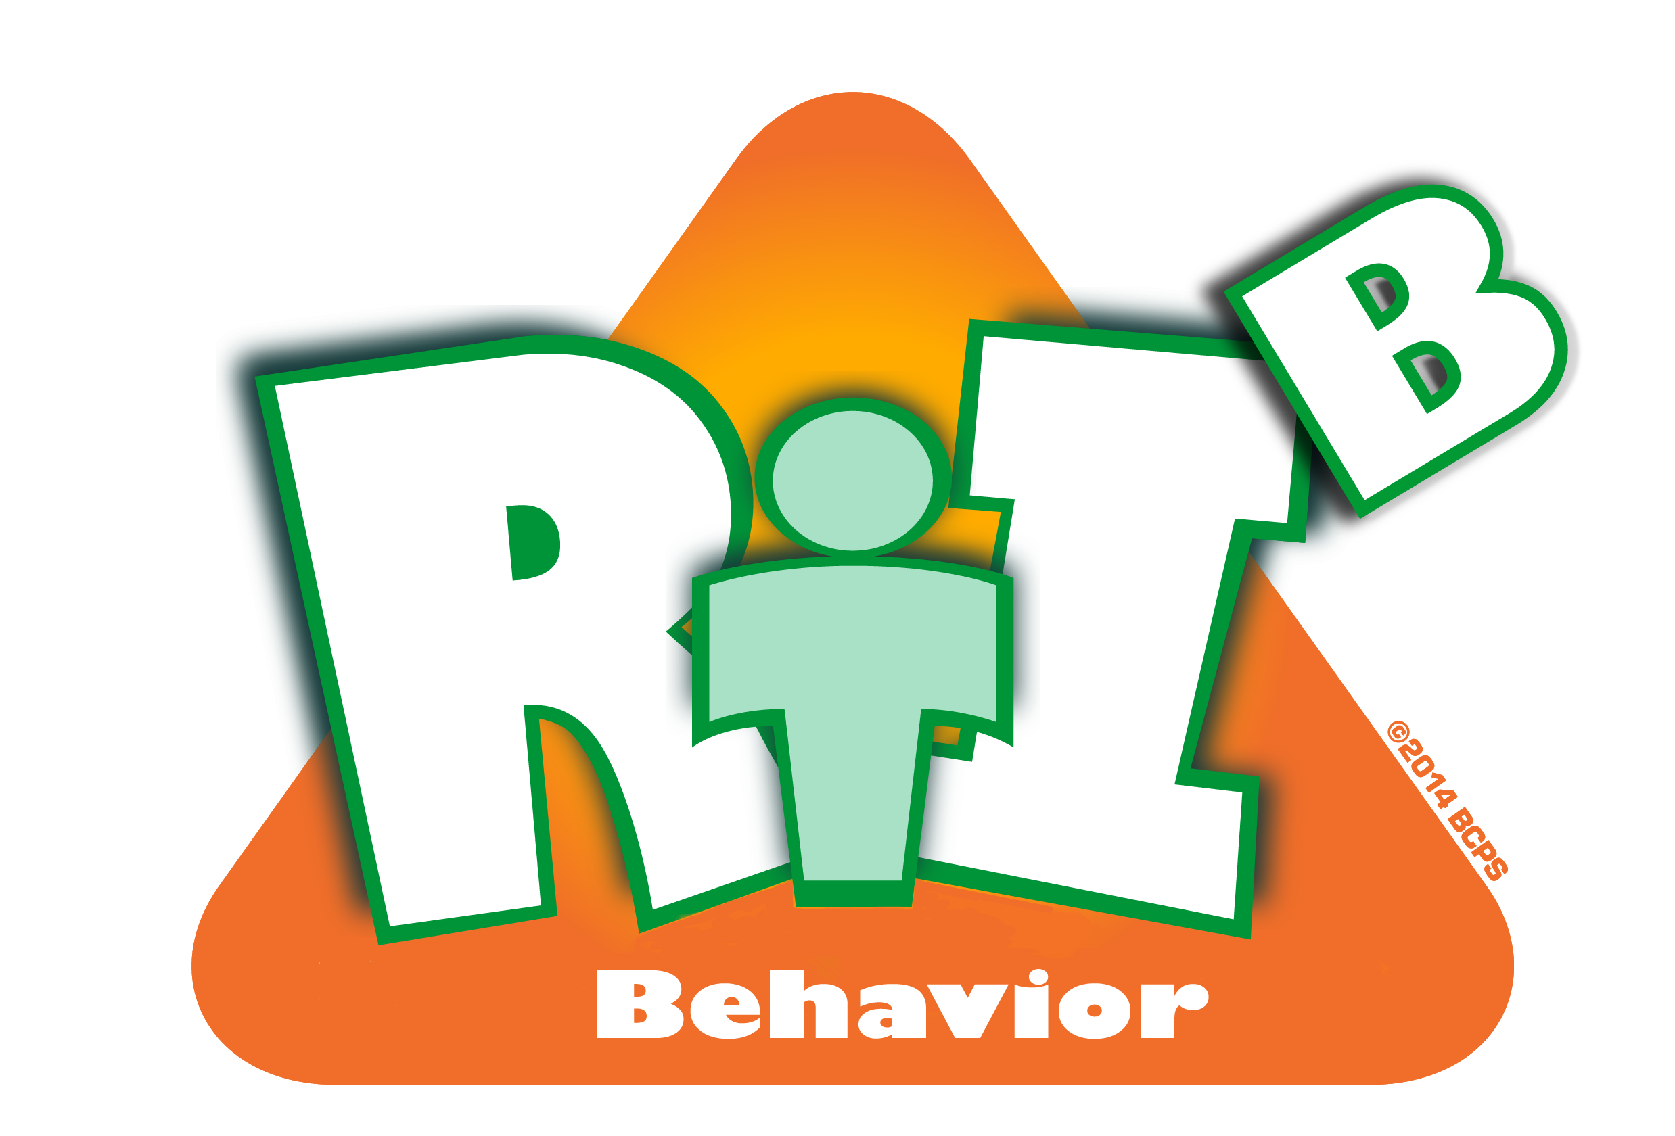
Broward County Public Schools

RtI:B Action Plan Guide

Data Entry and Analysis
CE
4
Critical Element
Data Entry & Analysis
Critical Element | Considerations | To-do List | Person Responsible | Follow up or  Completion Date
 | Data system to collect and analyze ODR data | Create a system to collect data regularly
 | Data system to collect and analyze ODR data | Create a criteria for determining success/failure of implementation and need for system modification
 | Additional data collected  (attendance, grades, faculty attendance surveys, etc.) | Determine other relevant data and analyze
 | Data is entered a minimum of weekly | Develop a plan for collecting data.
 | Data is entered a minimum of weekly | Create a back-up plan so data is always collected

 | Data is analyzed a minimum of monthly | Develop and document a schedule.
 | Data is shared with team and faculty a minimum of monthly | Schedule presentations in school calendar
 | Data is shared with team and faculty a minimum of monthly | Create a method for collecting and addressing feedback
 | Other:

