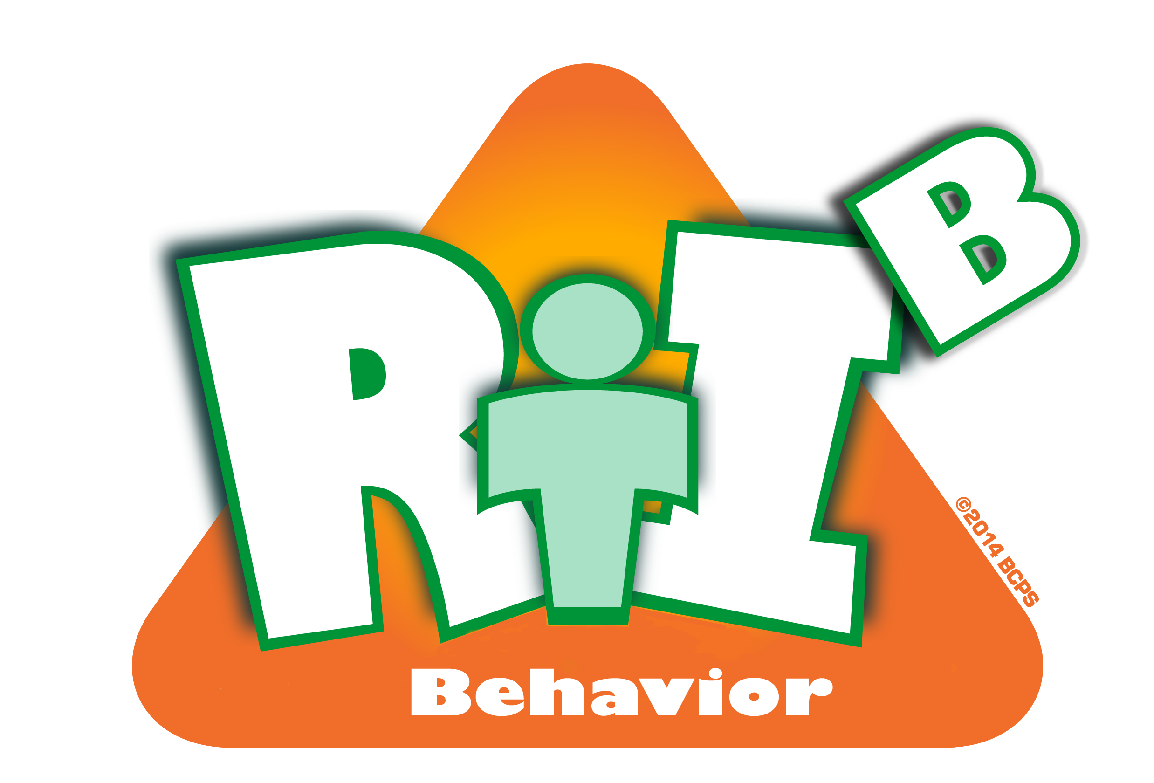
Broward County Public Schools

RtI:B Action Plan Guide

Expectations and Rules
CE
5
Critical Element
Expectations & Rules
Critical Element | Considerations | To-do List | Person Responsible | Follow up or  Completion Date
 | Staff provide feedback and are involved in expectations/rules development | Create staff surveys, questionnaires, etc. and provide method for participation and feedback
 |  | Create staff presentations, discussions, votes, etc.
 | 3-5 school-wide expectations | Check that all expectations follow global, positive criteria and apply to everyone on campus
 | 3-5 school-wide expectations | Post around entire school in all locations
 | 3-5 school-wide expectations | Create additional support for infusing expectations into school culture: “Marketing”
 | Expectations apply to everyone on campus including students, staff, parents, and visitors | Test expectations
 |  | Teach to staff and all stakeholders

 | 3-5 Rules are developed for specific locations | Check that all Rules follow the measurable and observable criteria
 | 3-5 Rules are developed for specific locations | All “public” locations have rules posted
 | Rules are linked to expectations | How are the rules reflected through the expectations?
 | Other:

