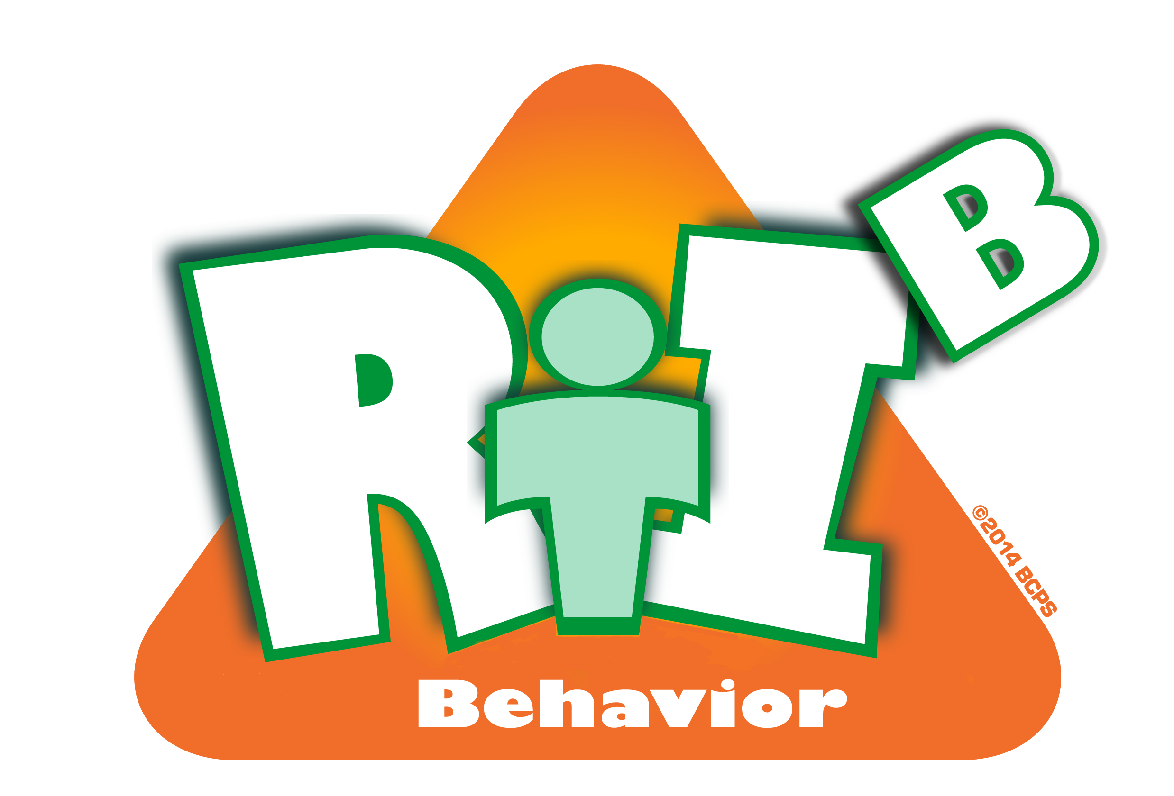
Broward County Public Schools

RtI:B Action Plan Guide
CE
6
Critical Element
Rewards and Recognition Procedures
Rewards & Recognition
Critical Element | RtI:B Considerations | To-do List | Person Responsible | Follow up or  Completion Date
 | A system of rewards has elements that are implemented consistently | Development of school-wide system
 |  | Teaching of staff, students, and stakeholders
 |  | Schedule switching of variety of rewards
 | An array of short term and long term rewards are available | Students are surveyed for desired rewards
 | An array of short term and long term rewards are available | Funding is developed for tangible incentives
 | An array of short term and long term rewards are available | A variety of rewards are developed and constantly modified
 | Rewards are linked to Expectations and the SPBP

 | System includes opportunities for intrinsic reinforcement | How can extrinsic rewards be shaped to intrinsic value?
 | System includes opportunities for intrinsic reinforcement | How can rewards further develop self-confidence, satisfaction, and skills?
 | Ratios of reinforcement to corrections are high | How to monitor staff ratios?
 | Ratios of reinforcement to corrections are high | Provide incentives to staff – develop staff reward system
 | Other:

