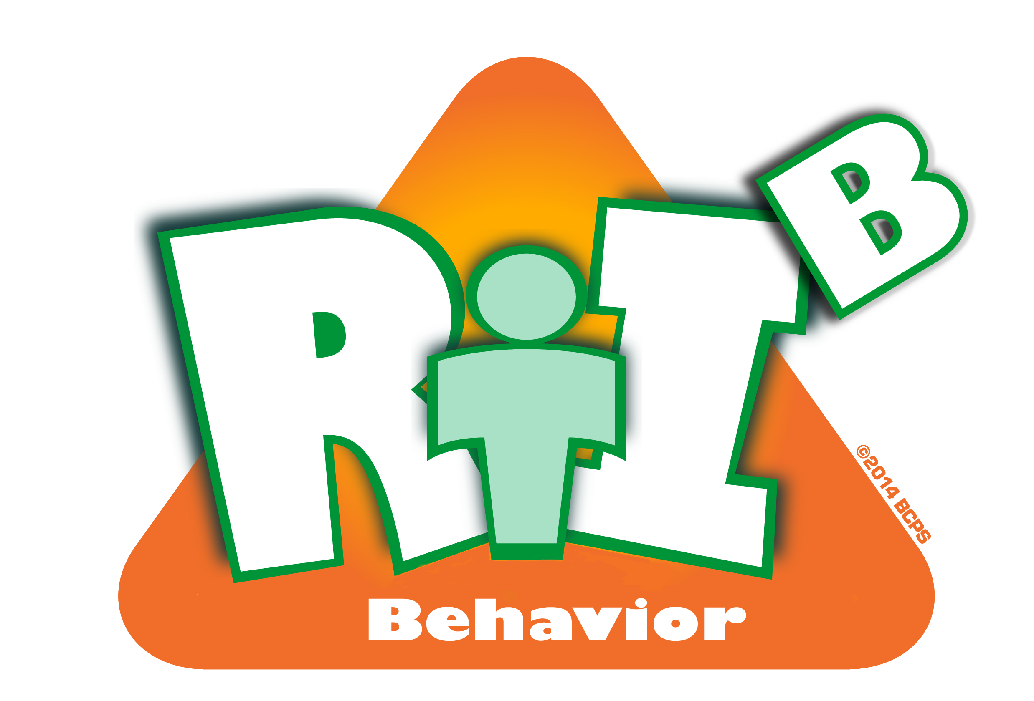
Broward County Public Schools
CE
8
Critical Element

RtI:B Action Plan Guide

Implementation Planning
Implementation Planning
Critical Element | Considerations | To-do List | Person Responsible | Follow up or  Completion Date
 | Develop, schedule, and train staff on Tier 1 Behavior Curriculum: Discipline Procedures | Develop, schedule, and train staff on MINOR and MODERATE level staff-managed misbehaviors
 |  | Develop, schedule, and train staff on Office-managed (Office Discipline Referral) misbehavior
 | Develop, schedule, and train staff on Tier 1 Behavior Curriculum: Rewards and Recognition | Develop a plan for how rewards are scheduled, delivered, and monitored
 |  | Create incentives for staff to participate
 | Develop, schedule, and train staff on Tier 1 Behavior Curriculum:  Lesson Plans for students | Develop a plan for how behavior lesson plans are scheduled, delivered, and monitored

 | Provide booster sessions for students and staff | Schedule a booster at least 2 times per school year
 | Provide booster sessions for students and staff | Provide method for staff feedback
 | Provide orientation for new students and staff | Create a simple, consistent, documented method
 | Develop, schedule and plan for involving families and community | Plans to involve stakeholders in development
 |  | Plans to inform stakeholders of implementation
 | Other:

