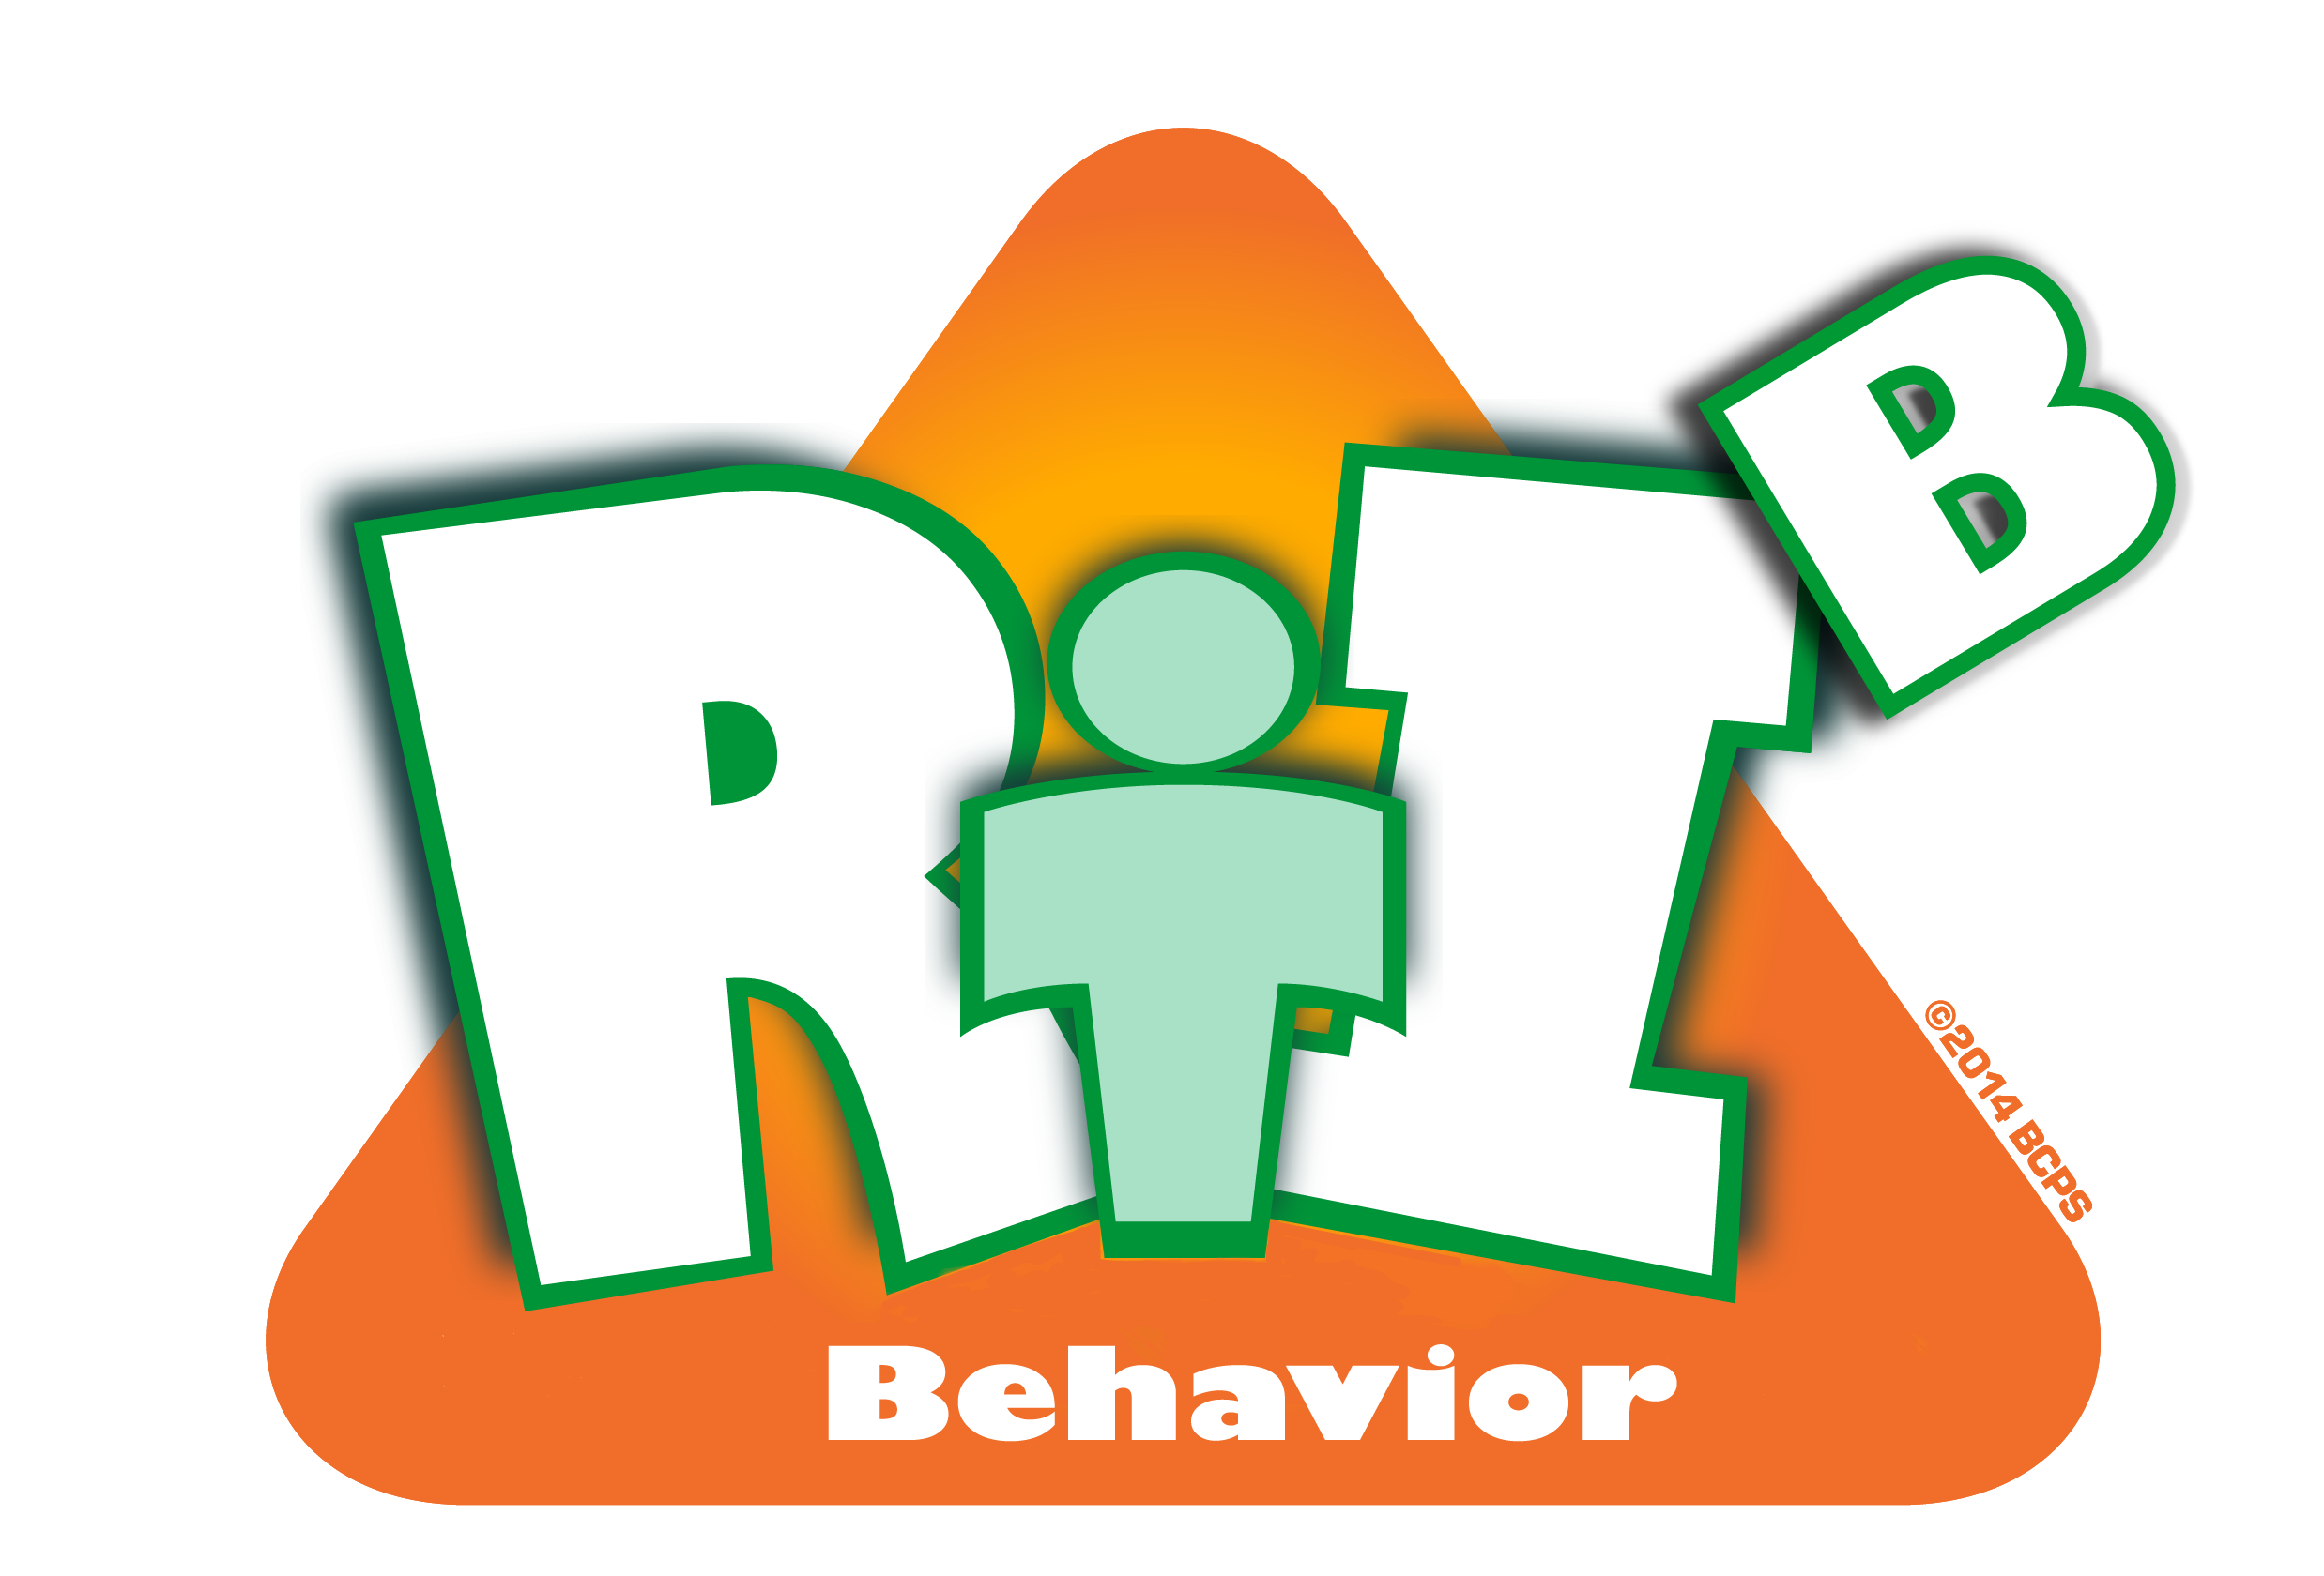
Broward County Public Schools
CE
9
Critical Element

RtI:B Action Plan Guide

Classroom Planning
Classroom Planning
Critical Element | Considerations | To-do List | Person Responsible | Follow up or  Completion Date
 | Rules are defined in each classroom and connected to the school-wide expectations | Post school-wide expectations in each classroom
 |  | Ensure teachers connect and post classroom rules
 | Routines and procedures are explicitly identified, taught, and documented | Teachers use consistent method to document routines and procedures
 |  | These are available to visitors and substitute teachers (CHAMPs Classroom Management Plan)
 | Praise in used in a minimum of a 3:1 ration | Provide teacher training on praise procedures  (CHAMPs)

 | Acknowledgement of adherence to OR disregard of classroom rules includes reference to rules and expectations | Provide teacher training on encouragement and re-direction procedures (CHAMPs)
 | A formal system tracks classroom behaviors of all levels: minor, moderate, and ODRs | Provide teacher training on types of quick and easy documentation systems (CHAMPs)
 | Classrooms have a range of consequences, including menu and accumulative consequences. | Provide teachers with school-wide menus for MINOR and MODERATE misbehaviors
 |  | Ensure teachers develop classroom rules/consequence chart (CHAMPs)
 | Other:

