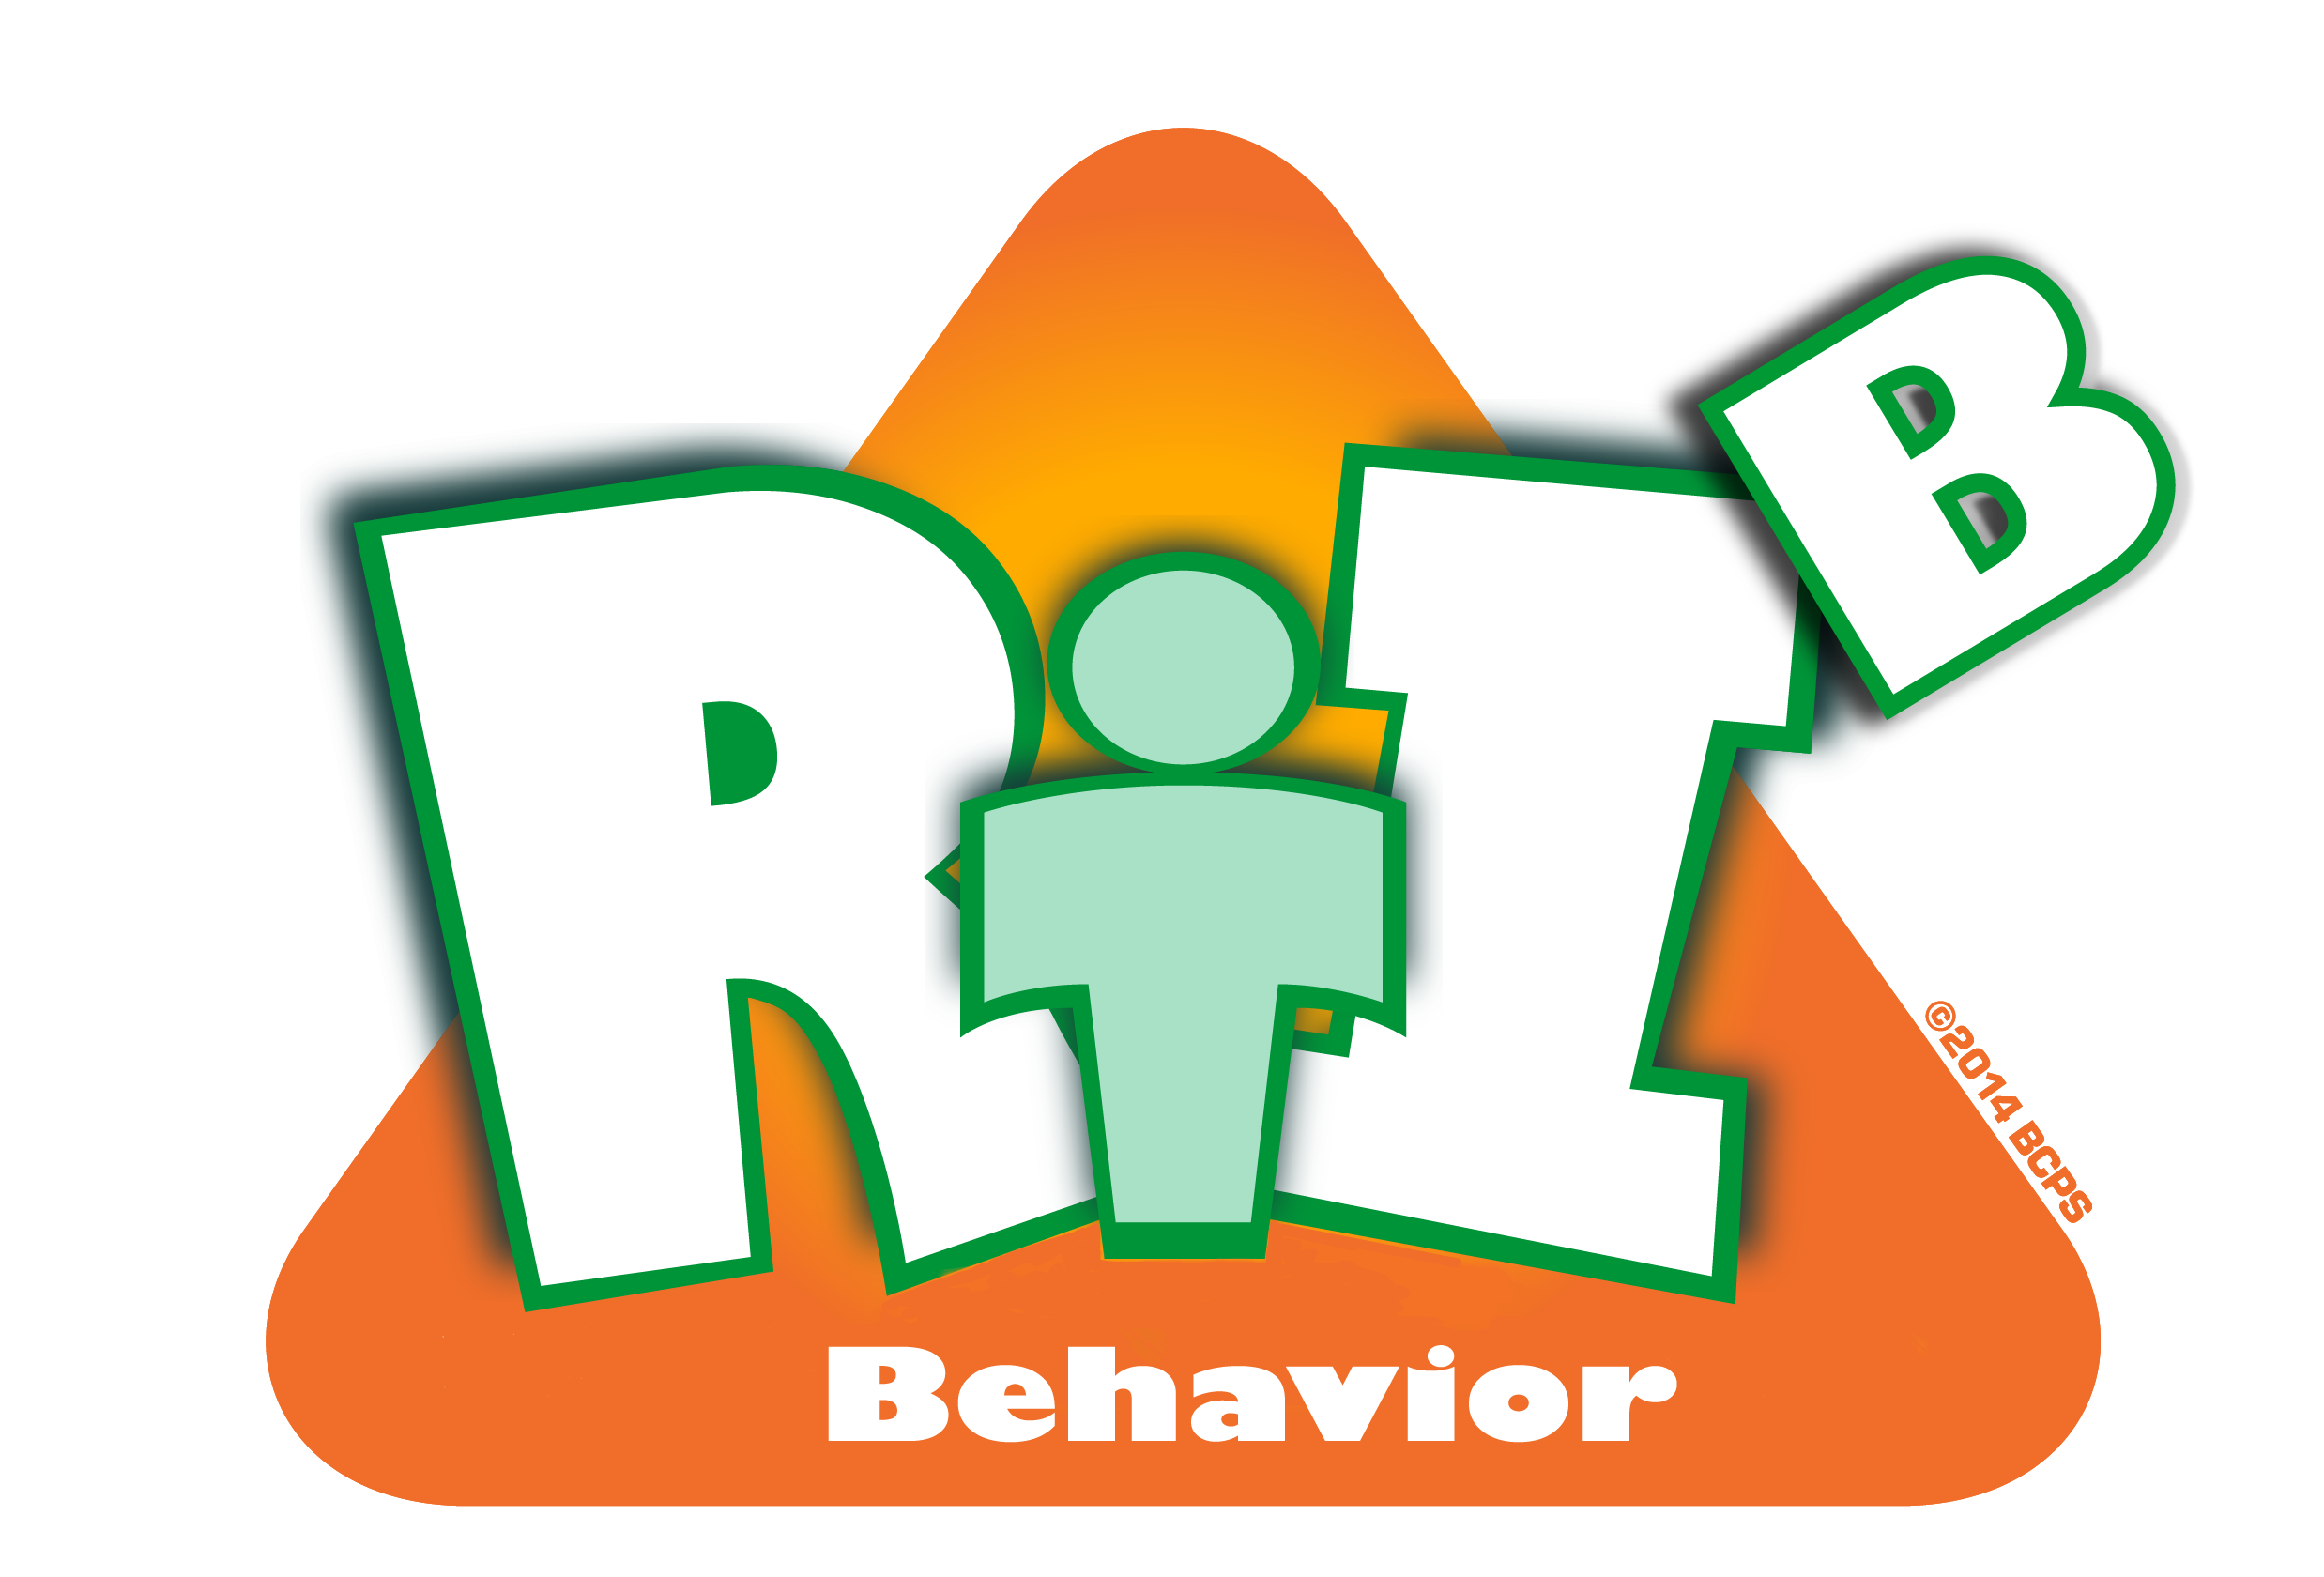

Broward County Public Schools  Diversity, Prevention & Intervention
7 Up: CHAMPs Checklist

School: __________________________________ Date:__________________ Time:__________________
Teacher PIN: ____________________________ Observer: ______________________________________

This ‘snap-shot’ checklist is intended to help teachers become more aware of effectively implementing the
7 CHAMPS Components. It should not be used for evaluation purposes.

Observer: Observe the class for 10 minutes. Check all that apply:
1. Structure: | Structure level provided: low med high  Structure level needed: low med high  physical layout of room matches structure level needed  activities/transitions “CHAMPed” out  routines and procedure posted and apparent  transitions completed in timely manner
2. Signal: | used during visit             not used during visit  used multiple times during visit n/a    visual auditory kinetic portable physical student response  100% students responded in 5 seconds. If not, approx. % responded: __________
3. Expectations: | clearly posted not seen during visit  same as school-wide Expectations  referred-to during visit to correct misbehavior  referred-to during visit to encourage/reinforce positive behavior
4. Rules: | clearly posted not seen during visit   3-5 rules positive observable specific  teacher follows Rule Menu or Hierarchy as posted  referred-to during visit to correct misbehavior  referred-to during visit to encourage/reinforce positive behavior
5. Corrective Consequences: | class-wide system clearly posted not seen during visit  negative consequence system defined (e.g. loss of points)            n/a  teacher follows system as posted  referred to during visit to correct misbehavior
5. Corrective Consequences: | verbal corrective consequences used during visit n/a  calm tone seamless consistent immediate    instructive re-directive followed up by positive interaction
6. Encouragement Procedures: | class-wide system clearly posted not seen during visit  reinforcement/reward system defined (e.g. earning points)           n/a  system defines incentives  teacher follows system as posted  referred to during visit to correct misbehavior  referred to during visit to encourage/reinforce positive behavior
6. Encouragement Procedures: | Count interactions for 10 min: |  | 3:1 ratio of positive to negative interactions  1:1 ratio of positive to negative interactions  negative ratio of interactions: _______ : ________
6. Encouragement Procedures: | Positive Tally | Negative Tally
7. Engagement  Strategies | teacher used 1 OTR during visit none used during visit  teacher used more than 1 type of class-wide OTR  teacher used 2 or more OTRs during visit  teacher used at least one engagement strategy below:    competition challenge cooperation connection  curiosity controversy choice creativity
For further information, please contact DPI at Broward County Public Schools: 754-321-1655.

