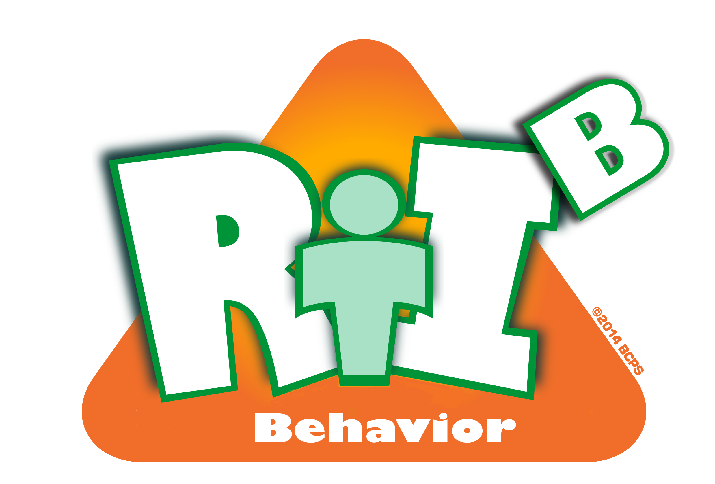
- What is your understanding of Positive Behavior Support (PBS)? (circle one)

Strong Moderate Minimal No understanding

- What are your biggest struggles in the classroom? Please list all.

______________________________________________________________________________________________________________________________________________________________________________________________________
______________________________________________________________________________________________________________________________________________________________________________________________________

- As a staff member what would be rewarding for you in your efforts? (circle all that apply)

Gift Certificates School logo shirt Extra school/office supplies

Other suggestions: _________________________________________________________

- What kind of reward systems do you use in your classroom?

______________________________________________________________________________________________________________________________________________________________________________________________________
______________________________________________________________________________________________________________________________________________________________________________________________________

- Do you feel supported?

Always Sometimes Seldom Never

- As a teacher what behavior interventions do you think would be effective?

______________________________________________________________________________________________________________________________________________________________________________________________________
______________________________________________________________________________________________________________________________________________________________________________________________________

- What method do you prefer to receive communication?

Email Mailbox Large staff meetings Small team meetings

Other: ___________________________________________________________________________________________________

