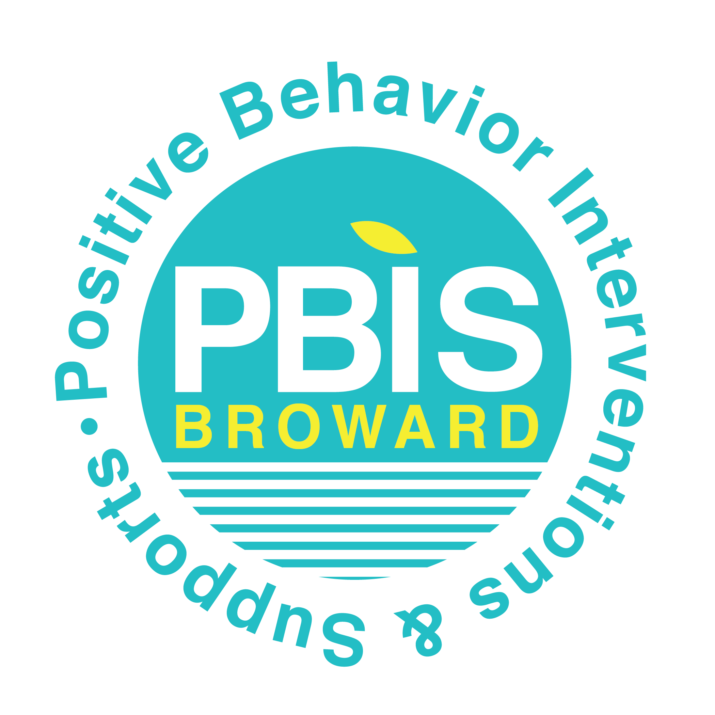
Date: __________Time: ________________ Facilitator: _____________________ Timekeeper: ___________________ Recorder: ______________________
Participants: _______________________________________________________________________________________________________________________
NEXT Meeting date, time, & location: ___________________________________________________________________________________________________

Agenda Item | Notes
Any follow-up items from last meeting:

Review Data by: | Data Reviewed (can attach graphs/data) | Significant Outcome
1. Core Effectiveness/
Student
2. Type of Behavior

3. Time of Day/
Time of Year (monthly)

4. Location

5. Teacher/
Grade Level

Time in Meeting | Problem Solving: (Choose only 1 or 2 Significant Outcomes to work on)
__:___ – __:___ | Problem ID: Based on the data review outcome, identify one or two problems to work on. Do you need to collect additional data to verify?
__:___ – __:___ | Problem Analysis: Why is this problem occurring? Consider fidelity of the Critical Elements. Use ICEL by RIOT to investigate hypotheses.
__:___ – __:___ | Plan Development and Implementation: Create research-based interventions. Specific details and interventionist to be documented.  Update your RtI:B Action Plan & SPBP as indicated
__:___ – __:___ | Plan Evaluation and Follow-Up: Determine criteria for success of implementation fidelity AND student outcome fidelity. Follow up action and Date.  Update your RtI:B Action Plan & SPBP as indicated

Communication: Teaching & engagement of staff, students and families/community (Update your Action Plan with these items)
What will be shared? | How will it be shared? | When will it be shared? | Who is responsible?
Date:

Time:

Location:
Diversity, Prevention & Intervention Department
754-321-1655
Additional resources at: www.browardprevention.org/mtssrti/rtib/ Teaming

