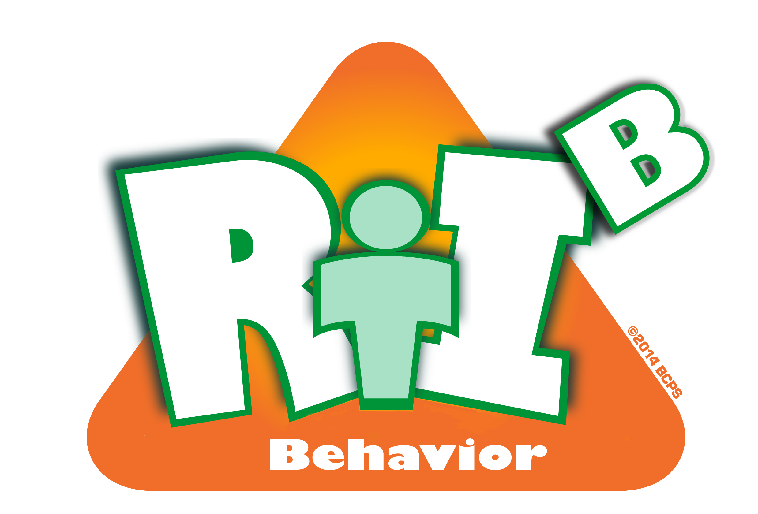
Broward County Public Schools
Diversity, Prevention & Intervention Dept.

RtI:B Tier 1 Data Collection

SCHOOL | Meeting Date:
PRINCIPAL | RtI:B Point of Contact:
PERIOD OF DATA COLLECTION: | ☐Year To Date  ☐From: To:

1. REFERRALS BY STUDENT/CORE EFFECTIVENESS
Total Population: |  | Calculation to  determine % rate | % | Core Evaluation
# Referrals | # Students | Calculation to  determine % rate | % | Core Evaluation
1 Referral |  | (Total Pop − (# of 2-5 Students) − (# of >5 Students)) ÷ Total Pop = |  | Students maintained through SPBP.  Students may need supplemental support  (0-1 Referrals should be >80%)
2-5 Referrals |  | (# of 2-5 Students) ÷Total Pop = |  | At Risk Students – Supplemental Strategy? Group support? Refer to CPST?  (2-5 Referrals should be <15%)
>5 Referrals |  | (# of >5 Students) ÷Total Pop = |  | Hi Risk Students – Intervene with CPST and individual or group supports  (>5 Referrals should be <5%)
Document Names:

Implications/Hypotheses:

 |  | 2. REFERRALS BY GRADE LEVEL/TEACHER
TEACHER OR GRADE |  |  |  | # STUDENTS | % TOTAL POPULATION | # ODRs | % REFERRALS
1.
2.
3.
4.
5.
TOTAL: |  |  |  |  | 100% |  | 100%
Implications/Hypotheses:
Compare Percentages

3A. REFERRALS BY TIME OF YEAR (MONTHLY)
# REFERRALS

A S O N D J F M A M J
Implications/Hypotheses:

3B. EVENTS BY TIME OF DAY
Highest Referral Times of Day | Activity/Location/Curriculum
1. ________________ to ________________
2. ________________ to ________________
3. ________________ to ________________
Implications/Hypotheses:

4. EVENTS BY LOCATION
Location: | #
Classroom (focus on classroom management strategies, such as CHAMPs)
1.
2.
3.
Implications/Hypotheses:

5. INCIDENTS BY BEHAVIOR
Incident | # | Incident | #
1. |  | 6.
2. |  | 7.
3. |  | 8.
4. |  | 9.
5. |  | 10.
TOTAL
Implications/Hypotheses:

Additional Data Collection:
ADMINISTRATIVE ACTIONS
Top Administrative Actions:
1.
2.
3.
4.
5.
Implications/Hypotheses:

REFERRALS BY RACE VS POPULATION
Sub group | % of population | % of referrals
Asian
Black
Hispanic
Multi
Native
White
Implications/Hypotheses:
Compare Percentages
NOTE:
Referral: ODR for individual student -such as "John was fighting"
Event: an occurrence that may contain multiple referrals and incidents - such as "Fighting"
Incident: the coded behavior connected to referrals. There can be multiple incidents - such as ‘battery’ and "destruction of property" during the fight
Action: the consequence imposed by Admin - such as "parent conference " or "no action". Actions are imposed based on the most severe incident of the event

